TASK -1(15-07-2024)

<html>

<head>

<title>About HTML</title>

</head>

<body>

<h1> HTML </h1>

<p>HTML is the standard markup language for Web pages.<br>

With HTML we can create your own Website.</p>

<img src="./html-logo.png" alt="img of html logo" heigth="100" width="100">

<p>

HTML is the standard markup language for creating Web pages<br>

HTML describes the structure of a Web page<br>

HTML consists of a series of elements<br>

HTML elements tell the browser how to display the content<br>

HTML elements label pieces of content such as "this is a heading", "this is a paragraph", "this is a link", etc.

</p>

</body>

</html>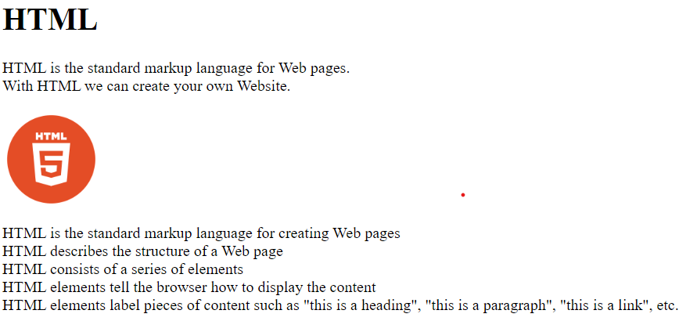

Screenshort of task-1

TASK 2(15-07-2024)

<html>

<head>

<title>About CSS</title>

</head>

<body>

<h1> CSS </h1>

<p>CSS is the language we use to style a Web page.</p>

<img src=".css-logo.png" alt="img of css logo">

<p>

CSS stands for Cascading Style Sheets

CSS describes how HTML elements are to be displayed on screen, paper, or in other media<br>

CSS saves a lot of work. It can control the layout of multiple web pages all at once<br>

External stylesheets are stored in CSS files

</p>

</body>

</html>

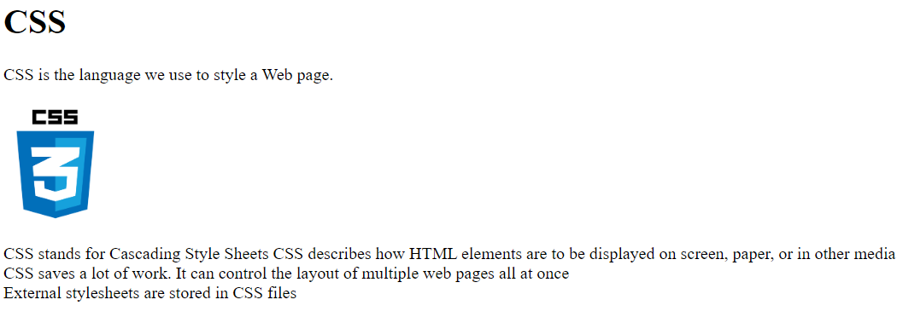

Screenshort of task 2.

TASK 3(15-07-2024)

<html>

<head>

<title>About JavaScript</title>

</head>

<body>

<h1> JavaScript </h1>

<img src="./javascript-39404.png" alt="img of css logo">

<p>

JavaScript is a lightweight, cross-platform, single-threaded, and interpreted compiled programming language. It is also known as the scripting language for webpages. It is well-known for the development of web pages, and many non-browser environments also use it.

</p>

</body>

</html>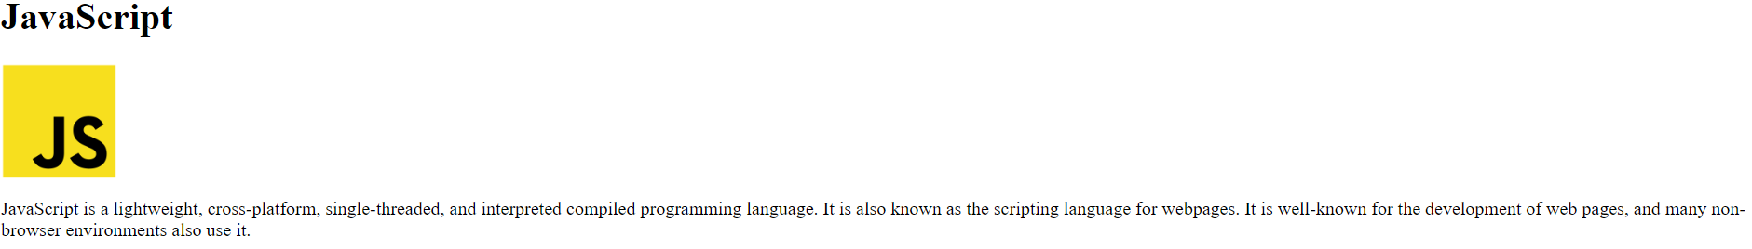

Screenshort of task 3.